FORM 2

THE PATENTS ACT, 1970
(39 OF 1970)

COMPLETE SPECIFICATION

Title of the Invention:

FLOATCHAT: AN AI-POWERED CONVERSATIONAL INTERFACE FOR
ARGO OCEAN DATA DISCOVERY AND VISUALIZATION USING
HYBRID GEOSPATIAL-SEMANTIC RETRIEVAL AND REAL-TIME
DATA SYNCHRONIZATION

Applicants:

1. S. Kishore (RA2311003020702)
2. S. Imran Ahamad (RA2311003020714)
3. Gundluru Yashovardhan (RA2311003020717)

Department of Computer Science and Engineering
SRM Institute of Science and Technology, Ramapuram
Bharathi Salai, Ramapuram, Chennai – 600 089
Tamil Nadu, India
Supervised by:
Mr. K. Rajesh
Assistant Professor, Department of Computer Science and Engineering
SRM Institute of Science and Technology, Ramapuram

Nationality of Applicants: Indian

THE FOLLOWING SPECIFICATION PARTICULARLY DESCRIBES THE INVENTION AND THE MANNER IN WHICH IT IS TO BE PERFORMED.

1. FIELD OF THE INVENTION
This work is about building a smarter way to access and understand ocean data using artificial intelligence. More specifically, we developed a system that lets users ask questions about ARGO float data in plain English, without needing to know any programming or database query language. The system combines natural language processing, a hybrid search approach, and automated data synchronization to make oceanographic data more accessible. In this case, the focus is on ARGO float data, but the approach can generally be extended to other types of scientific sensor data as well. The work sits at the intersection of AI, data management, and marine science, and we believe it addresses a real gap in how ocean data is currently accessed and explored.
2. BACKGROUND OF THE INVENTION
ARGO is one of the biggest ocean observing programs around the globe. It uses roughly 4,000 robotic floats drifting in the oceans. These robotic floats dive deep, about 2,000 meters in depth, collecting such information as temperature, salinity, pressure, and oxygen as they ascend back towards the surface. Upon reaching the surface, data is sent to the satellites, which in turn transfer it to repositories where it becomes freely accessible for the general public in NetCDF format. NetCDF is a standard binary file format popular in scientific applications related to climate and oceanography.
The issue here is that despite the data being available in public access, processing that data is far from simple. In our work on this project, we faced this challenge firsthand. Here are a few issues we found:
(a) Technical Difficulty of Using Data File Format: The NetCDF files are rather sophisticated; they come in binary form. This means they cannot be accessed without specialized software and technical skills.
(b) Huge Amounts of Diverse Data: The amount of data generated by the ARGO program over several decades is immense. In addition, it covers practically every ocean on the planet. Search for the data required through traditional database management will take too long.

(c) Lack of Automated Data Update Procedure: There is currently no effective way of automatically updating one's local data collection. New data files should be downloaded from the FTP server manually each time an update is required.
(d) Lack of Natural Language Queries Capability: Any tool allowing for querying of the data in NetCDF files requires a particular set of skills. In this case, users need to be able to use SQL or other database languages. This may prove challenging for a marine biologist or any other professional who doesn't have programming experience.
(e) Limited Query Processing Capabilities: Suppose a user asks the question – "Show me the temperature anomaly close to Indian coastline during the monsoon season". This request includes spatial context, temporal aspect, and semantics – things regular SQL databases or keywords searches cannot handle individually.
These are the problems we aimed to tackle with this project.
3. SUMMARY OF THE INVENTION
We developed an approach named FloatChat which attempts to solve all aforementioned issues. The primary objective of FloatChat is to allow users to pose questions in natural language, allowing the system to interpret them, find and provide them with data and finally present this data to them in a manner that is meaningful for understanding. However, several unique technological solutions had to be developed in order to make this possible.
One of them we are going to talk about is the Hybrid Geospatial-Semantic Retrieval Pipeline. It can be summarized as follows - in most cases, oceanographic queries are geographically as well as semantically bound. For instance, when we ask about "what is the oxygen level in the Arabian Sea", the question refers to both geographical location (Arabian Sea) and semantic concept (oxygen, possibly represented by DOXY and dissolved_oxygen terms in the data). Dealing with both simultaneously is difficult. Our approach allows solving the issue in three steps. In the first step, we filter the profiles based on their location and timestamp using PostgreSQL. In the second step, we perform a semantic vector search with ChromaDB but restrict the pool to profiles returned by the first step filter. In the last step, we combine the spatial and semantic relevances with a weight-based formula.

Our second contribution is the Real-Time ARGO Data Synchronization Engine, which automates the process of downloading new NetCDF files from the official website and uploading them to the system's database by connecting to the official ARGO FTP server located at ftp.ifremer.fr. The synchronization engine knows how many files have been downloaded and compares them with those on the server in order to download only the latest ones.
Our third contribution is the Automated Ocean Research Report Generator. Once a user has completed their research or discussion with the AI assistant, they may request a PDF report that summarizes the results in the form of an oceanographic report. The system will collect all relevant profiles and produce maps and charts based on them. Next, it will calculate some statistics and use the language model to summarize its observations. Finally, the results will be converted into a downloadable PDF file.
4. BRIEF DESCRIPTION OF DRAWINGS
The drawings forming part of this specification and included herein serve to illustrate various aspects of the invention, along with the detailed description, to elucidate the principles of the invention.
Figure 1 illustrates an example of the general system architecture of the FloatChat invention.
Figure 2 illustrates an example of the three-stage Hybrid Geospatial-Semantic Retrieval Pipeline.
Figure 3 illustrates an example of the Real-Time ARGO FTP Synchronization Engine.
5. DETAILED DESCRIPTION OF THE PREFERRED EMBODIMENTS
The description below describes various embodiments of the invention. It will be understood by those of skill in the art that the invention can be practiced using some or none of the particular details described herein.
5.1 System Architecture Overview
Referring to Figure 1, the FloatChat system comprises the following primary components operably connected on a computing infrastructure:
Streamlit Web UI (10): This is the browser-based interface through which the user can issue their queries in natural language, browse oceanography data, and request visualizations and reports. The streamlit web interface has been created with the help of the Streamlit toolkit and runs on a web server that can be accessed through a web browser.
Query Processor (12): This block receives natural language queries issued by the users in the streamlit web UI (10) and extracts structured information such as the oceanography parameter(s) of interest, geographic region/coordinates, time frame/seasons, and individual float numbers.
Hybrid Retrieval Pipeline (14): This is the central novel feature of the present invention, and its architecture has been explained in detail in section 5.2. It communicates with the PostgreSQL database (16) and the ChromaDB vector store (18) for the retrieval of relevant oceanographic profiles.
PostgreSQL Database (16) houses structured oceanographic information in two main tables of relations. These include a profiles table that holds one entry per ARGO float dive and has variables such as float ID, geographic position (latitudes and longitudes), measurement time, cycle number, data type, quality control flag, and text description; and a measurements table with one entry per depth level of each profile and has variables such as depth, pressure, temperature, salinity, dissolved oxygen, nitrate, pH, chlorophyll, and calculated variables such as potential temperature, water density, and mixed layer depth.
The ChromaDB Vector Store (18) is an implementation of a vector database that stores 384 dimensional vectors of sentence embedding derived through natural language summaries of each oceanographic profile. This vector store uses all-MiniLM-L6-v2 sentence transformer model for deriving the vectors and offers semantic search capability. During its initial implementation phase, the vector store was preloaded with the documentations on oceanography containing explanations and definitions about various oceanographic variables (temperature, salinity, pressure, oxygen, nitrate, pH, chlorophyll), oceanographic phenomena (thermocline, mixed layer depth, water mass), and geographical location of different seas (Arabian Sea, Indian Ocean, Bay of Bengal).
LLM API (20): Inference for Large Language Models such as Groq API with the LLaMA 3.3 70B model and OpenAI GPT API are provided as configurable alternatives as the LLM API backends. The LLM takes the input in the form of natural language question along with the relevant retrieved oceanographic profile data as context and produces a factually accurate natural language response. The prompt to the LLM directs the latter to provide answers based on only the available context and also requires references to the floats, date and values obtained.
ARGO FTP Server (22): The ARGO FTP Server means the official FTP repository for ARGO Global Data Repository located on ftp.ifremer.fr server, with directory structure based on the region of ocean, years and months of observation, where file naming is as follows YYYYMMDD_prof.nc.
The Real Time Sync Engine (24) is described in detail in Section 5.3.
The PDF Report Generator (26) is described in detail in Section 5.4.
5.2 Hybrid Geospatial-Semantic Retrieval Pipeline
As seen in Figure 2 below, the Hybrid Geospatial-Semantic Retrieval Pipeline makes up the first and most significant novel contribution of the current invention. The retrieval process goes through the following three distinct stages:
Stage 1 – Spatial Filter (12): Following the receipt of structured query parameters from the Query Processor (12), the system applies a spatio-temporal filter to the PostgreSQL Database (16). During the spatial filter stage, a SQL query is formulated that selects records with a latitude falling within the bounding box generated from the geographic region referred to by the user’s query, a longitude falling within the corresponding longitudinal range, and the measurement date being within the appropriate time frame. The purpose of this step is to reduce the size of the candidate profiles from a very high number, ranging in the tens of thousands to just 50–500 relevant records.
Stage 2 – Semantic Search (14): The list of profile identifiers that resulted from Stage 1 is submitted to the ChromaDB Vector Store (18) as a filter condition. The query from the user in plain text gets transformed into a vector of dimensionality 384 using the all-MiniLM-L6-v2 sentence transformer. ChromaDB conducts its vector similarity search on a set of profiles filtered through Stage 1 using the L2 distance metric only on the list of pre-filtered profiles instead of conducting the search on the entire database. The resulting list of profiles from this search is scored with L2 distance values, which get normalized using the following equation:_similarity_score = max(0.0, 1.0 - L2_distance).
Stage 3 – Score Fusion (16): This stage fuses together the scores obtained from the previous stages based on a weighted fusion score that produces the final relevance score for each candidate profile. The weighted score fusion equation is formulated as:
Final Score = (0.4 x Spatial Score) + (0.6 x Semantic Score)
where Spatial Score represents the spatial relevance score calculated in stage 1, which is essentially an indicator of the geographic proximity of the profile relative to the region centroid in the query. Semantic Score denotes the similarity score obtained in Stage 2. The weights used in the above equation, namely, 0.4 and 0.6, have been optimized empirically based on oceanography domain queries for precision in retrieval. Top-k scores generated are grouped together to construct a context block and submitted to the LLM API (20).
The technical impact of the Hybrid Geospatial-Semantic Retrieval Pipeline is increased accuracy in complex oceanographic natural language queries, when compared to using either spatial filtering or semantic vectors alone. The reason for this is because an oceanographic query will have both geospatial elements as well as semantic elements, which makes it a problem that requires both methods to be addressed properly.
5.3 Real-Time Incremental ARGO Data Synchronization Engine
As shown in Fig. 3, the second novel aspect of the invention is the Real-Time ARGO Data Synchronization Engine. The synchronization engine functions in the following way:
Following a triggered synchronization event (10), which can be initiated either by the system administrator or automatically on a scheduled basis, the engine will open an FTP session with the designated ARGO database at ftp.ifremer.fr (12). The engine will then move through the hierarchical file structure within the FTP database until it locates the latest data in the Indian Ocean geographic area at /ifremer/argo/geo/indian_ocean/.
The engine fetches the list of profile files for each day based on their name YYYYMMDD_prof.nc and then compares the dates with the last synchronization date stored in the database (16). If there are no new files, then the process will end in the End state (18). However, in case there are new files, the engine downloads the new NetCDF files that have not been downloaded earlier (20).
For each NetCDF file downloaded, the NetCDF Processor (22) is used to load the file using xarray, determine the format of the file (ARGO or general oceanographic file type) based on the detection of certain ARGO parameters (PRES, TEMP, PSAL), and convert any variations in the naming conventions of the parameters between data sources to internal standard parameter names. The processed profile entries are inserted into the PostgreSQL database (24). Embedding vectors for the new profiles are added to the ChromaDB vector index (26). The last synchronization time stamp is set to the date of the last processed file (28), and synchronization is completed (30).
The technical impact of the Real-Time Incremental ARGO Data Synchronization Engine is that it removes the need for manual downloading and processing of the data, thus allowing FloatChat to have a continuously updated database of present-day ocean measurements without any human involvement.
5.4 Automated Ocean Research Report Generator
The Automated Ocean Research Report Generator represents another innovative part of this invention. Once requested by the user through the Streamlit Web UI (10), the following automation process takes place within the Report Generator:
The data about oceanographic profiles to be generated is retrieved from the PostgreSQL Database by the generator according to the user's request. With the help of Plotly data visualization library, the generator automatically generates depth profile graphs for the chosen profiles depicting temperature, salinity and other indicators as functions of depth. With the help of Folium data visualization library, the generator generates a map depicting geographic locations of the chosen ARGO floats.
The generated output is a set of statistics on the retrieved oceanography data, namely the minimum, maximum, average, and standard deviations of the values of all the recorded parameters within the chosen depth. The statistics, oceanography profile data, and visualization data are combined to create the context payload, which is then used by the LLM API (20) to generate an executive summary in natural language about the findings from the data.
The next step is compiling all of the above-mentioned elements – depth profile graph, map of the geographical location, table containing statistics, and the story written by the language model – into one PDF file, which is accomplished via a Python library for creating PDF files. The resulting PDF file becomes available for downloading through the Streamlit Web UI (10). The technical outcome is an automatic creation of professional oceanography research reports in just a few minutes.
5.5 Data Processing and Quality Control
There is also an integrated component in the system for transforming and quality checking the data gathered from the sensors used by ARGO. This component follows the standards set by ARGO for setting quality flags to filter bad values, which include parameter values exceeding the valid ranges based on physical reality: temperature of −5°C to 50°C, salinity of 0 to 50 PSU, pressure of 0 to 10,000 dbar, and dissolved oxygen of 0 to 500 µmol/kg. Data falling outside this range will be tagged as bad data with a quality flag of 4. The system also provides the computation for additional oceanographic parameters such as potential temperature, approximate seawater density, and mixed-layer depth.
6. CLAIMS
We claim:
1. An artificial intelligence-based solution for the discovery and visualization of ARGO oceanographic float datasets using natural language processing, including: a web-based application for capturing user queries; a query engine that can identify spatial, temporal, and parameter information; a hybrid retrieval pipeline that can search and retrieve geospatial and semantic data; a large language model interface to generate answers based on the retrieved information; a data synchronization engine that downloads ARGO NetCDF datasets from the FTP server; and a report generation tool that generates downloadable visual and analysis reports.
2. A system according to claim 1 is adapted to perform a geospatial-semantic hybrid retrieval process which comprises: (i) a spatial filter phase where the relational database is queried based on geospatial and temporal criteria to yield candidate identifiers of profiles; (ii) a semantic search phase where a vector similarity search is performed with the restriction of the candidate profile identifiers; and (iii) the calculation of an overall relevance measure based on a weighted combination of the spatial and semantic relevance measures.
3. Claim 2 system, wherein the vector database comprises embedding vectors generated based on natural language descriptions of oceanographic profiles and is pre-loaded with relevant domain knowledge before data insertion.
4. System according to claim 1, characterized in that said data synchronization engine is capable of accessing a hierarchical remote repository, determining newly generated data files through temporal metadata with respect to a recorded synchronization timestamp, selectively downloading the determined files, and recording the updated synchronization timestamp after completing the process.
5. As claimed in claim 1, the invention relates to a system that includes a report generating unit which retrieves information and generates a visualization along with statistics, creates a natural language summary using the language model, and then compiles them all together to create a report.
6. An oceanographic data retrieval system based on a computer-implemented method comprising: receiving a natural language query; extracting spatial and temporal information; conducting a spatial filter to identify possible data points; conducting a semantic search within vector embeddings restricted to possible data points; calculating an aggregated similarity measure between the query and possible data points; and returning ranked results based on the aggregated similarity measure.
7. Computer-implemented method for synchronization of oceanographic data, including steps of: accessing a remote data store; determining availability of new data according to a recorded synchronization timestamp; selectively downloading said new data; importing and persisting said data records into a database; updating a data vector; and updating said synchronization timestamp.
8. The process described in claim 7 involves the processing of all downloaded files to parse structured data files, represent parameter standardizations, validate the quality of the data, and calculate one or more derived parameters.
7. ABSTRACT
Oceanographic float data from autonomous profiling platforms serve as an important source of information for studying the marine environment; however, accessing and analyzing such data is hindered by the massive size and complexity of the data structure. In the current state-of-the-art techniques for oceanographic float data acquisition, there exists a strong preference towards employing manual query methods, keyword search engines, or visual tools, hindering efficient browsing and analysis of complex and vast amounts of data. Moreover, there is a need for incorporation of geospatial filter together with semantic understanding of the data, as well as real-time updates of data and automatic creation of analytical reports. The invention disclosed herein is a computer-implemented method and apparatus referred to as FloatChat, implementing an AI-enabled natural language-driven approach for oceanographic float data discovery and visualization. The method utilizes a hybrid geospatial-semantic data retrieval pipeline, performing a process involving geospatial filtering using a relational database for oceanographic data, vector similarity search of the filtered data and weight scoring fusion of results, enhancing the process of data retrieval. Additionally, the proposed invention comprises a real-time incremental synchronization engine detecting new oceanographic profile data in a remote database by comparing timestamps and then ingesting the detected new data into relational and vector databases. Outputs include geospatial maps, depth profiles, descriptive statistics and generated natural language description.
DRAWINGS
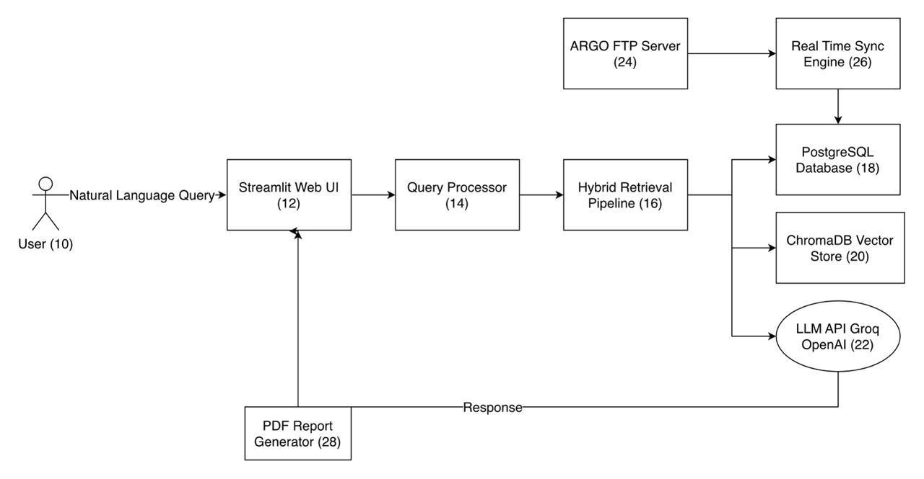

Figure 1: Overall System Architecture of FloatChat

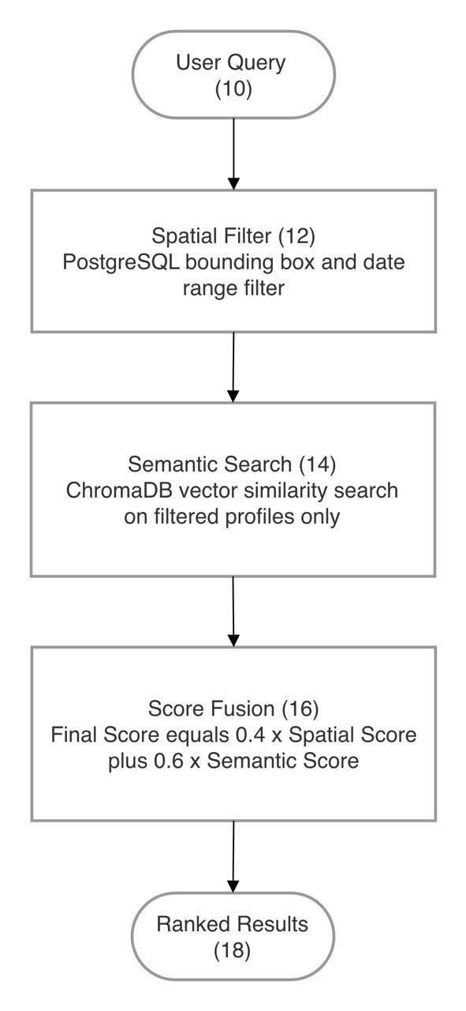

Figure 2: Hybrid Geospatial-Semantic Retrieval Pipeline

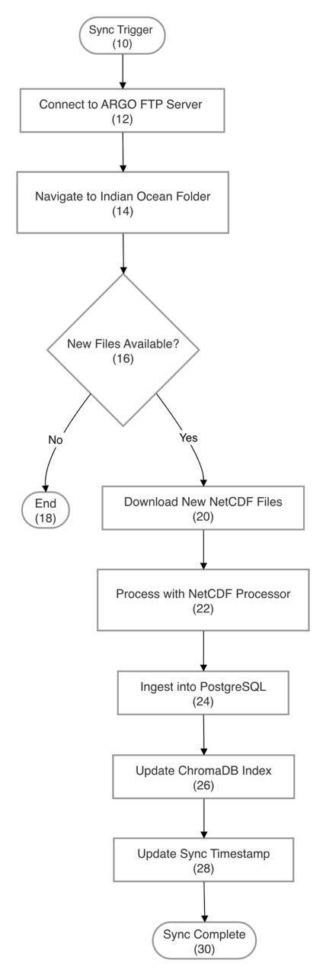

Figure 3: Real-Time ARGO FTP Synchronization Engine

DECLARATION

This declaration is hereby made that the present invention, as described in the above complete specification, is an original invention by us and, as far as we know, has neither been published nor used anywhere else in India or abroad in any way prejudicial to the interest of the applicants.

We are the true and first inventors of the subject matter of this complete specification.

Inventors / Applicants:

1. S. Kishore (RA2311003020702)

Signature: ________________________ Date: _______________

2. S. Imran Ahamad (RA2311003020714)

Signature: ________________________ Date: _______________

3. Gundluru Yashovardhan (RA2311003020717)

Signature: ________________________ Date: _______________

Guided by:

Mr. K. Rajesh
Assistant Professor, Department of Computer Science and Engineering,
SRM Institute of Science and Technology, Ramapuram
Bharathi Salai, Ramapuram, Chennai – 600 089, Tamil Nadu, India

Signature: ________________________ Date: _______________

Place: Chennai, Tamil Nadu, India

Date: 26th March 2026

